DIPLOMA IN
AVIATION BUSINESS MANAGEMENT

TWO YEARS PROGRAM
COURSE OUTLINES

PART I & PART II

SINDH BOARD OF TECHNICAL EDUCATION

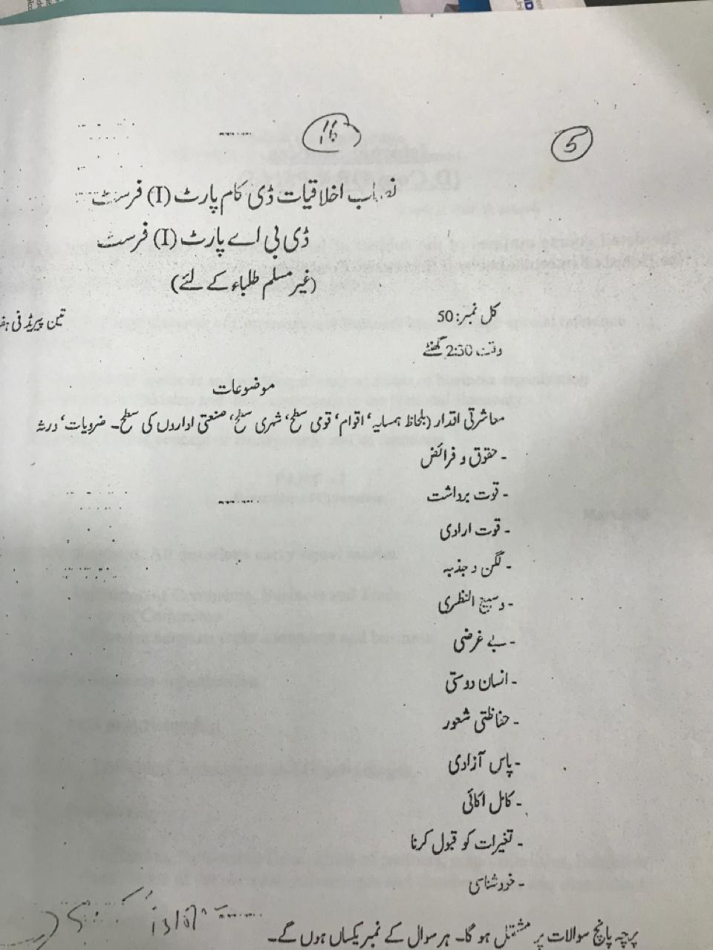

MINIMUM ELIGIBILITY CRITERIA / REQUIREMENTS
FOR INSTITUTIONS CONDUCTING
DIPLOMA IN AVIATION BUSINESS MANAGEMENT - DABM

FACILITY: The institution that is desirous of conducting the above course should have at least four spacious classrooms, multimedia, a library with adequate books (at least 500 relevant books and magazines, with at least 50 aviation management books and periodicals), computer lab with at least 15 workstations, Windows 10, MS Office, good internet connection.
The facility should have adequate separate washrooms for Girls and Boys. Canteen facility should also be available. Provision of some sports activity at the facility is preferred.
FACULTY: The institution must have at least 6 faculty members with at least 3 with Master level education and 3 with at least Bachelor level education. At least 3 faculty members must have Aviation Management related education and experience of at least 5 years.
ORGANIZATION: The institution must be at least an SECP registered Private Ltd company or a registered Partnership concern. Alternatively, the institution could be under relevant regulations of the Companies Ordinance/Societies Registration Act/Trust Act as a Foundation/Society or a Trust. The institution must have at least 4 administrative staff on board.
Minimum Eligibility Criteria for Students: Age of the students enrolled for the program would be at least 15 years. The student should have passed either Matric or cleared O’ Level.

DIPLOMA IN
AVIATION BUSINESS MANAGEMENT

PART I
Scheme of Studies

SINDH BOARD OF TECHNICAL EDUCATION

Scheme of Studies for
Diploma in Aviation Business Management
Part I

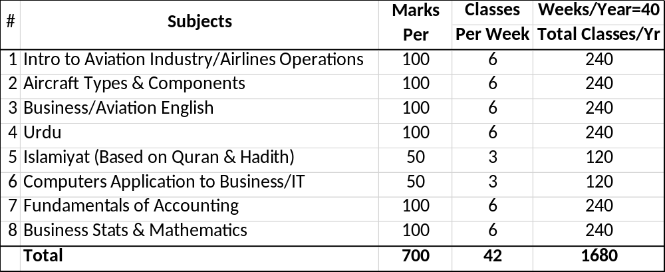

Diploma in Aviation Business Management -DABM- Part – I
AVN 101 : INTRO TO AVIATION INDUSTRY/ AIRLINES OPERATIONS

Total Marks : 100 Periods Per Week: 6
General Objectives
The course is intended as an introductory course for those who are considering aviation profession; or gain a historical perspective of the development of aviation and aerospace. The course also introduces basic concepts of aviation business, principles and practices associated with the aviation industry. The current status of the aviation business industry is also introduced.

PART - A
Introduction to Aviation Industry
Marks : 40
Topics that are covered in the course are:
- Aviation History from Inception
- Aviation History of Pakistan
- Aviation Commercial Business Terms

- Differentiation of Classes of Aviation
- Aeronautics, Aerospace and Avionics
- How does an aircraft fly and major controls and instruments?
- Props, turboprops, jet engines, turbojets and rockets (basic intro and characteristics)
- Impact of Aviation on Global economy
- Airlines’ marketing & pricing – demand and supply (an overview)
- Weather & Atmosphere

PART - B
Airlines Operations
Marks : 60
Introduction to Airlines Operations
- Airlines – A Service Industry
- Nature of Service
- Airlines Organizational Structure – Typical
- Airlines Operation
  - Flight Operations
  - Flight Services
  - Operational Control
  - Technical Services
  - Materials Management
  - Flight Safety & Standards
  - Training
  - Flight & Operational manual
- Scheduling
  - Schedule formation
  - Information in Schedule
  - Dissemination of Information to users
- Product
  - Service Level Definition
  - Passengers Amenities
- Pricing
  - Pricing Policy
  - Competition & Pricing
- Distribution Channels
  - Description
  - Advantages to Customers
  - Advantages to Airlines
- Airport Slot Management
  - What is Slot
  - IATA Slot Conferences
  - Slot Coordination among Airlines
  - Two Typical Schedules in the Industry
- Airport Services
  - Passengers Checking Procedures
  - Flight Controls
  - Passengers Boarding
  - Passenger counting, documentation
  - Baggage Services
  - Lost & Found Services
- Marketing & Promotion
  - Channels used
  - Strategies
  - Creativity and challenges
  - Product Image
- Strategic Decision making
- The economic way of thinking in aviation business
- Characteristics of demand for Air Transportation
- Competition and mode of operations
- Safety & Security regulations and compliance
- Passenger surveys and improving customers handling
- Cooperation & coordination with partners
- Airport coordination committees
- Working with Civil Aviation Authorities

Recommended Books:
- Introduction to Aviation Management, by Andreas Wald, Christoph Fay and Ronald Gleich

- Aviation History (JS319008) – A Jeppesen Publication, by Anne Marie Millbrook

Diploma in Aviation Business Management -DABM- Part – I
AVN 102 : AIRCRAFT TYPES & COMPONENTS

Total Marks : 50 Periods Per Week: 3
General Objectives
The course covers basic introduction to aircraft parts, systems, and history of development of aircraft over the years since inception.
Course Contents
Aircraft Structure
- Aircraft is like a flying Bird
- Aircraft main parts
  - Fuselage – main body of Aircraft
  - Wings, structure
    - Fixed Parts
    - Moving Parts
  - Engines
    - Types
    - Engines thrust
    - Engine mounting
  - Tail - Empennage
    - Tail functioning
    - Importance of tail in flying control
  - Undercarriage (Landing Gears)
    - Functioning
    - Number of tires
    - Types of brakes
- Major Differences between Boeing & Airbus aircraft
- Elaborative pictures of different aircraft
- Small regional and other commercial aircraft
- Training and civil Service aircraft operation
Aircraft Types
Military Aircraft
Civil Aircraft
Fighter Airplanes
Sub Sonic, Super Sonic, Hyper Sonic Aircraft
Single aisle and wide-bodied aircraft
Types by Configuration
Types by range & endurance
Height, Altitude, Elevation (Airfields and Aircraft)

Recommended Books:
- Trends in General Aviation, Kamala I. Shetty and R. John Hansman
- Understanding Flying: A commonsense practical approach to the basics of flying. Everything you need to know about General Aviation, by Richard L. Taylor, 2006

(Diploma in Aviation Business Management -DABM- Part – I
AVN 103 : ENGLISH

Total Marks : 100 Periods Per Week: 6

The detail course outlines of the subject of English will be the same as of Board of Intermediate and Secondary Education.

(Diploma in Aviation Business Management -DABM- Part – I
AVN 104 : URDU
Total Marks : 100 Periods Per Week: 6

The detail course outlines of the subject of Urdu will be the same as of Board of Intermediate and Secondary Education.

AVN 105 : نصاب اخلاقیات
(Diploma in Aviation Business Management -DABM- Part – I
For NON-Muslim Students
Total Marks : 50 Periods Per Week: 3

(Diploma in Aviation Business Management -DABM- Part – I
AVN 105 : ISLAMIC STUDIES
Total Marks : 50 Periods Per Week: 3

The detail course outlines of the subject of Islamiyat will be the same as of Board of Intermediate and Secondary Education.

Diploma in Aviation Business Management -DABM- Part – I
AVN 106 : Computers Application to Business/IT
Total Marks : 100 Periods Per Week: 6

GENERAL OBJECTIVES
After the completion of the course the students have the knowledge of:
- Computer basics
- Word Processing
- Handling the office equipment
- Simple programming

COURSE CONTENTS
EDP
- Introduction to computers
  - Definitions
  - Computer Structures (Input, Output, CPU)
  - Types of Computers (Digital, Analog, Hybrid)
  - Computer Generations
- Number System
  - Representation and Conversion
  - Binary, Decimal and Hexadecimal
  - Concept of storage Address: Bit, Byte, Parity Bit, odd & Even Parity Bit
- Computer Codes
  - ASCII
  - EBCDIC Codes
  - Packed Decimal Form
- Introduction to File Organization
  - Master and Transaction
  - Sequential and Random
  - Indexed and Dynamics
DOS
- Introduction to File DOS
  - Operating System
  - Configuration, System File
  - Autoexec batch file
- INTERNAL DOS COMMANDS
  - CLS, DATE, TIME, VER, VOL, DEL., COPY, DIR
- EXTERNAL DOS COMMANDS
  - CHKDSK, DISKCOPY, DISKCOMP, XCOPY, SYS. TREE
VISUAL BASIC
- Starting Out with Visual Basic
  - What is Computer Program
  - Computer Programs and Programming Languages
  - Signing Your Program
  - The Importance of Designing Your Program
  - How Design Fits into the Programming Process
  - Program Design in a Nutshell
- Introduction
  - Fundamental of Visual Basic Programming
  - Working with Visual Basic Components
  - Creating Application Interfaces
  - Database Programming Techniques
  - Additional References
  - Conventions and Special Elements
- Creating Your First Program
  - Creating Your Program’s User Interface
  - Getting Started
  - Saving Your Work
  - Getting Information from The User
  - Adding a Text box Control
  - Labeling Your Program’s Controls
  - Adding a Command Button
  - Changing a Form’s Properties
  - Saving Your Again
  - Coding Your Program’s Actions
  - Responding to Events
  - Specifying Event Procedures
  - Writing Program Code
  - Running Your Program
- Visual Basic Building Blocks
  - Forms
  - Using Controls
  - Exploring Properties
  - Forms Properties Revisited
- Controlling the Flow of Your Program code
  - Working with text
  - Control for making choices
  - Special purpose control
  - Working with multiple control at design time
  - Working with control collection
- Microsoft Common Controls
  - Introduction to the Common Controls
  - Organizing Your Data
  - Accepting User Input

Recommended Books:
    - Aviation Information Management By Thomas L. Seamster, Barbara G. Kanki
    - Introduction to Personal Computers for Students, by Axzo Press (latest edition)

Diploma in Aviation Business Management -DABM- Part – I
AVN 107 : FUNDAMENTALS OF ACCOUNTING

Total Marks : 100 Periods Per Week: 6
GENERAL OBJECTIVES
The objective of this course is to provide the students with a knowledge of accounting to enable them to prepare financial statement for different types of business such as Non-profit organizations and sole proprietorship, prepare financial statements of companies, compute and interpret working capital ratios and analyze various items of current assets and liabilities to highlight the current financial position of the companies and this course explain potential matters that should be considered while making a regulatory framework for published accounts.
COURSE CONTENTS:
1. Introduction of Financial Accounting and Principles:
1.1 The Impact of International Accounting Standards as Applicable in Pakistan for the Preparation of Financial Statements and Their Disclosure Requirement.
1.2 Forms of Business Enterprises such as Non-profit Organization, Sole Proprietorship, Partnerships and Corporation.

2. Financial Statements – The Outputs of the System
2.1 Objectives of Financial Reporting
2.2 Qualitative Characteristics of Financial Information
2.3 The Uses and Limitations of Classified Balance Sheets
2.4 The Uses and Limitations of Classified Income Statements
2.5 The Retained Earnings Statement or Statements of Changes in Stockholders’ Equity

3. Inventory Accounting:
3.1 Nature and Classes of Inventories
3.2 Periodic and Perpetual Inventory Valuation as per International Accounting Standard (IAS-2)
3.3 LIFO, FIFO Methods, Weighted Average Method, Moving Average
3.4 Inventory Valuation at Cost or NRV, whichever is lower

4. Cash Flow Statement
4.1 Preparation of Cash Flow Statements According to the Requirement of IAS
4.2 Classification of Cash Flow Statements as Operating Activities
4.3 Investing Activities and Financial Activities by Using Direct and Indirect Methods

5. Interpreting Financial Statement Data
5.1 Users of Financial Statements and the Purposes of Financial Statement Analysis
5.2 The Techniques and Tools of Financial Analysis
5.3 Common Financial Ratios, Common Size Balance Sheet and Income Statement
5.4 Limitations of Financial Statement Analysis

6. Accounting for Receivables
6.1 Accounting for Receivables Under Income Statement and Balance Sheet Approach
6.2 Notes Receivable and their Matters

7. Current Liabilities and Accounting for Long Term Liabilities
7.1 Definition and Recognition of Liabilities
7.2 Types of Current Liabilities
7.3 Types of Long-Term Liabilities
7.4 Bonds
7.5 Accounting for Bonds by Borrowers
7.6 Accounting for Bonds by the Investor
7.7 Other Forms of Long-Term Debt
7.8 Time Value of Money Concept

Recommended Books:
- Weygandt, Kieso, Kimmel, Financial Accounting, John Wiley and Sons, Inc.,2nd Edition,1998.
- Meigs Robert F., Williams Jan R., Haka Susan F., Bettner Mark S., Accounting, McGraw Hill, 10 Edition, 1999.

Diploma in Aviation Business Management -DABM- Part – I
AVN 108 : BUSINESS STATISTICS & MATHEMATICS
Total Marks : 100 Periods Per Week: 6
GENERAL OBJECTIVES
After studying this course, the student will know how to collect the data, its nature, its average value and variation in it. The student will be able to compare the variability of two or more heterogeneous groups. The student can compare the prices, quantities and values etc. of a group of related articles at one date with those of the same group of related articles at different date.

PART A
BUSINESS STATS
MARKS: 50
COURSE CONTENTS
1. Defining the Role of Statistics in Business
1.1 Definition of ‗Statistics (Singular Sense and Plural Sense)
1.2 Application of Statistics in Business
1.3 Four Basic Activities of Statistics
2. Classification and Tabulation of Data
2.2 Quantitative and Qualitative Data
2.3 Tabulation of Discrete Data
2.4 Tabulation of Continuous Data
2.5 Concept of Mid Point
2.6 Concept of Cumulative Frequencies
3. Graphical Representation of Data
3.1 Preparation of Histogram
3.2 Frequency Curve
4. Representation of Data through Diagrams
4.1 Bar diagram and Multiple Bar Diagram
4.2 Rectangles and Subdivided Rectangles
4.3 Pie Diagram or Sector Diagram

PART B: BUSINESS MATHEMATICS
MARKS: 50
COURSE CONTENTS
1.1 Preliminaries
1.2 Basic Algebra
1.3 Ratios
1.4 Proportions
1.5 Percentages
2.1 Linear Equations and Inequalities
2.2 System of Linear Equations
2.3 Linear Functions and Its Application
2.4 Simultaneous Equations
2.5 Break – Even Models
3.1 Mathematical Functions in General
3.2 Types of Functions
3.3 Graphical Representation of Functions

Recommended Statistics Book:
Weiss Neil A., Introductory Statistics, Addison–Wesley Publishing Co. (7th Edition), June2004.

RECOMMENDED MATHEMATICS BOOK:
Budnick Frank S., Applied Mathematics for Business Economics and Social Sciences, McGraw Hill, 1993.

DIPLOMA IN
AVIATION BUSINESS MANAGEMENT

PART II
Scheme of Studies

SINDH BOARD OF TECHNICAL EDUCATION

Scheme of Studies for
Diploma in Aviation Business Management
Part II

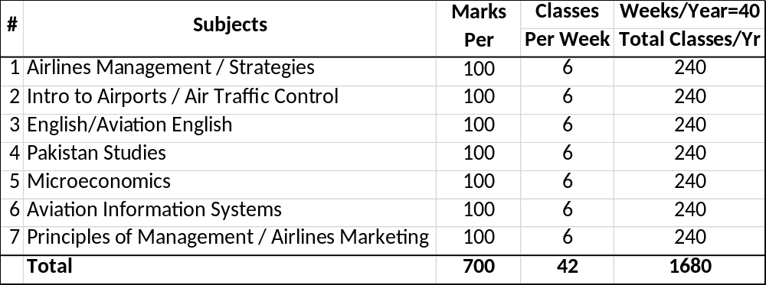

Diploma in Aviation Business Management -DABM- Part – II
AVN 201: AIRLINES MANAGEMENT / STRATEGIES

Total Marks: 100 Periods Per Week: 6
GENERAL OBJECTIVES
An introduction to the administrative aspects of airline operation and management is provided in this course. Besides the importance of airlines strategies in the keen competition era will be covered.
PART A
AIRLINES MANAGEMENT
MARKS: 60
COURSE CONTENTS
1. Introduction
- A brief introduction to airlines business
- Importance of best management practices in airlines industry
- Unique business model
2. Airline Management and Organization
- Airlines Industry is a Service Industry
- Scope of the business
- Cultural impact
- Organizational Structure and scope of responsibilities
3. Management
- Defining goals and objectives
- Establishing responsibilities
- Inter/Intra departmental cooperation
- Reporting systems

- Functions of Management
  - Executive Management
  - Middle Management
  - Scope of responsibilities
  - Distribution of authorities
6. Organization/ Organizational Charts
a. Typical
b. An airline specific
7. Staff Departments
- Definition
- Scope
- Reporting Level
- Inter departmental relationship
8. Line Departments
- Definition
- Scope
- Reporting Level
- Inter departmental relationship

9. The Marketing Mix
- Service Industry As against Production Industry
- 4 Ps
- Service definition in Airline Industry (Product)
- Pricing of Services (Pricing of Product)
- Route/Frequencies (Placement of Product)
- Promotion

Recommended Book
Airline Operations and Scheduling, by Massoud Bazargan

PART B
AIRLINES STRATEGIES
MARKS: 40
GENERAL OBJECTIVES
In the era of keen competition, Airlines have to have a strong base for having clear and visionary strategies, This part of course is an introduction to the strategic aspects of airline operation and management. The students are expected to understand how important is developing strategies and carrying them to sustain business.

COURSE CONTENTS
      - Strategy
        - Defining a Strategy
        - Different forms of Strategies
        - Marketing Strategies
        - Operational Strategies
        - Financial Strategies

      - Corporate Strategy
        - Typical Strategy
        - Scope of Strategy
        - Impact of Corporate Strategy

      - Marketing Strategies
        - Competing advantage of a good Marketing Strategy
        - Product Strategy
        - Pricing Strategy
        - Placement Strategy
        - Promotional Strategy

      - Operational Strategies
- Operational Efficiency
- Smooth operation & resources utilization
- Cooperation between Technical & Operations
- Availability of resources
Recommended Book: Airline Industry: Strategies, by Connor R. Walsh

Diploma in Aviation Business Management -DABM- Part – II

AVN 202: INTRO TO AIRPORTS / AIR TRAFFIC CONTROL

Total Marks : 100 Periods Per Week: 6
GENERAL OBJECTIVES
The purpose of this course is to introduce students to the airports which are focal point in aviation industry. What is structure of airports and how different activities are coordinated. Air Traffic Control system is also an integral part of airports. Elements and requirements of the course will include basic air traffic control procedures for pilots, navigation aids, control tower operations, radar approach and departure regulations, and airport traffic control (ATC).

PART A
INTRO TO AIRPORTS
MARKS: 50
GENERAL OBJECTIVES
The student will be presented with an opportunity for the study of the organizational, political, and financial administration of public and private civil use airports. Areas of emphasis include public relations management, safety and security issues, employee organizational structures,

COURSE CONTENTS
- Traditional airport basics
- Airports and Aerodrome
- Airport Markings
- Runway Nomenclature
- Importance of commercialization
  - Ownership
  - Commercialization
  - Privatization basics
- Why privatization? The privatization timetables
  - Pros and Cons of privatization
  - Policy and Regulations
- The airport operators.
  - Operations
  - Administration
  - Safety & Security
- Revenue and cost structures
  - ICAO Regulation
  - Best Practices
  - Issues in Revenue collection
- Factors inﬂuencing costs and revenues
  - Cost details
  - Containing Costs
- Differentiation of service levels. Service quality
  - Service Levels and Standards
  - Best practices
- Security issues
  - Responsibility of Security
  - Incidents of Security Breaches
  - Lessons Learnt
  - Future trends
- Environmental Impact of Airports
  - Greenhouse effect
  - Noise abatement
  - Future trends
- The structure of aeronautical charges
- The airport regulatory environment

Recommended Book:
Moving Boxes by Air, by Peter Morrel (Latest edition)

PART B
AIR TRAFFIC CONTROL
MARKS: 50
COURSE CONTENTS
- Air Traffic Control Procedures
  - Procedures and Phraseology
  - Communication procedures
- Identification Zones & Routes
  - Radars at Aerodromes
  - Precision Approach & Airport Surveillance
  - Radar Controlling and Non-radar controlling
  - Identifying aircraft and allocating routes
- Air Traffic Control Duties
  - Flight Data Controller duties
  - Clearance Delivery Controller duties
  - Ground Controller duties
  - Local Controller duties
- Other Aspects of Safety Concern
  - Wake turbulence
  - IFR & VFR
  - Collision Avoidance Systems
- Delegation of Responsibility
  - Handoff procedures
  - Communication and acknowledgement
- Separation Procedures
  - Vertical Separation
  - Lateral Separation
  - Holding Patters
  - Visual Separation
  - Overdue aircraft
- Approval Requests and Coordination
- Intro to Aeronautical Charts and Dead Reckoning
Recommended Book: Fundamentals of Air Traffic Control by Michael S. Nolan

Diploma in Aviation Business Management -DABM- Part – II
AVN 203: ENGLISH / AVIATION ENGLISH

Total Marks : 100 Periods Per Week: 6
The detail course outlines of the subject of English will be the same as of Board of Intermediate and Secondary Education.
Aviation English part is submitted below:
GENERAL OBJECTIVES
To learn about the concept and terminology used in Aviation.
Course Contents

Introduction to air communication

Pre-flight – checks, delays, local condition

Ground movements – Airport markings, taxiing and holding

Departure – climbing, cruising

Enroute events – Operational events, unusual events, medical emergencies

Contact and Approach – Descent, Circuit joining, Approach and Landing issues

Landing – Landing incidents, getting to the gate, communication.

List of abbreviations

ICAO – English Language Proficiency Test requirements

Recommended Book: English for Aviation
By Sue Ellis, Terence Gerighty

Diploma in Aviation Business Management -DABM- Part – II
AVN 204: PAKISTAN STUDIES

Total Marks : 100 Periods Per Week: 6
The detailed course outlines of the subject of Pakistan Studies will be the same as of the Board of Intermediate and Secondary Education

Diploma in Aviation Business Management -DABM- Part – II

AVN 205: MICROECONOMICS / MACROECONOMICS

Total Marks : 100 Periods Per Week: 6
GENERAL OBJECTIVES
The objective of this course is to provide basic understanding of economic principles to everyday life. Economic analysis will help the student to understand society with economic reasoning.

PART A: MICROECONOMICS MARKS: 50
Course Contents
1.Fundamentals of Economics
1.1 The Scope of Economics
a. Microeconomics and Macroeconomics
1.2 The Three Problems of Economic Organization: Market, Command and Mixed Economies

2. Demand, Supply, and Market
2.1 What is a Market?
a. Market Mechanism
b. How Markets Solves the Three Economic Problems
c. The Invisible Hand and the Perfect Competition
2.2 Demand, Supply and Equilibrium
2.3 Demand and Supply Curves
2.4 Behind the Demand Curve
2.5 Shifts in Demand Curve
2.6 Behind the Supply Curve
2.7 Shifts in Supply Curve
2.8 Equilibrium of Supply and Demand

3. Application of Supply and Demand
3.1 Elasticity of Demand and Supply
a. Price Elasticity of Demand
b. Calculating Elasticity
c. Elasticity and Revenue
d. Price Elasticity of Supply
e. Other Important Elasticity
4. Demand and Consumer Behavior
4.1 Choice and Utility Theory:
a. Determination of Household Choice
b. Budget Constraint
4.2 Basis of Choice: Utility
a. Diminishing Marginal Utility
b. Allocating Income to Maximize Utility c. Utility Maximizing Rule
d. Income and Substitution Effect
6. Analysis of Costs
6.1 Short Run Costs and Output Decisions
a. Fixed Cost
b. Variable Cost
c. Total Cost
7. Behavior of Perfectly Competitive Markets
7.1 Supply Behavior of Competitive Firm
7.2 Supply Behavior of Competitive Industries
8. Imperfect Competition: Monopoly, Duopoly and Oligopoly
8.1 Patterns of Imperfect Competition
8.2 Marginal Revenue and Imperfect Competition
8.3 Behavior of Imperfect Competitors
9. Factor Markets: Land, Labor, Capital and Income Distribution
9.1 Production Theory (Review)
9.2 Demand and Supply of Factors of Production
9.3 Determination of Factor Price by Supply and Demand

PART B

MACROECONOMICS
MARKS : 50
GENERAL OBJECTIVES
This course will enable the students to learn a new way of looking at the world. This course will establish students’ understanding of key economic issues.
COURSE CONTENTS
1. Introduction to Macroeconomics
1.1 The Roots of Macroeconomics (Great Depression + Recent Macroeconomic History)
1.2 Components of Macro Economy
a. Circular Flow diagram
b. Three Market Arenas
1.3 Macroeconomic Indicators:
a. Inflation
b. Aggregate Output and Business Cycle
c. Unemployment and Global Issues
1.4 The Role of Government in the Macro Economy
2. Measurement of Economic Activity
2.1 Gross Domestic Product
a. Final Goods + Services
b. Exclusion of Used Goods and Paper Transactions
c. Exclusion of Output Produced Abroad by Domestically Owned Factors of Production
2.2 Calculating GDP:
a. Expenditure – Approach
(i) Personal Consumption Expenditure (C)
(ii) Gross Private Investment (Ig)
(iii) Government Purchases (G)
(iv) Net Exports (Xn)
(v) The GDP Equation: C + Ig + G + Xn
b. Income – Approach
(i) Compensation of Employees
(ii) Rents
(iii) Interest
(iv) Proprietor’s Income
(v) Corporate Profits
(vi) Three Adjustments (Indirect business Taxes, Depreciation, Net–Foreign Factor Income)
2.3 Other National Accounts:
a. Net Domestic Product (NDP)
b. National Income (NI)
c. Personal Income (PI)
d. Disposable Income (DI)
2.4 Nominal versus Real GDP
2.5 Consumer Price Index (CPI)
2.6 Limitations of GDP Concept
4. Fiscal Policy
4.1 Introduction to Fiscal Policy
4.2 Instruments of Fiscal Policy
5. Monetary Policy
5.1 Introduction to Monetary Policy
5.2 Instruments of Monetary Policy
6. Balance of Trade
6.1 Export Transactions
6.2 Import Transactions
7. Balance of Payment
7.1 (a) Current Account
(b) Capital Account
(c) Official Reserves Account
7.2 Payment, Deficits and Surplus
Recommended Books: 1. Karl E. Case and Ray C. Fair, Principles of Economics, Prentice Hall international Inc. 8th Edition, 2007.
2. Samuelson, Paul A. and Nordhaus, William D., Economics, McGraw Hill Inc., 18th Edition, 2005.

Diploma in Aviation Business Management -DABM- Part – II

AVN 207: AVIATION INFORMATION SYSTEMS

Total Marks : 100 Periods Per Week: 6
GENERAL OBJECTIVES
In today’s era of technology, in Aviation Industry use of state-of-art technology can’t be over emphasized. The students of this course are expected to have a full exposure to different information systems used in different departments, and different functions.

COURSE CONTENTS
The course also contains the necessity and importance of Information Technology in Aviation. It covers some important Systems commonly used in the industry:
- Necessity & Importance of Information Technology in Aviation
- Aviation Information System
  - Define with examples
    - Aviation
    - Information
    - Systems
- Some commonly used Information Systems in Airlines
  - In-house developed
  - Off the shelf buying
  - Customization of systems
- Administrative Systems
  - Scope
  - Architecture
  - Reports
- Financial Systems
  - Scope
  - Architecture
  - Reports
- Operational Systems
  - Scope
  - Architecture
  - Reports
  - Regulatory requirements
- Technical Systems
  - Scope
  - Architecture
  - Reports
  - Regulatory requirements
- Revenue Management Systems
  - Scope
  - Architecture
  - Reports
  - Interfaces
- Catering Systems
  - Scope
  - Architecture
  - Reports
  - Interfaces
- Importance of Standardization
  - Key
  - Inter & Intra departmental
  - Global
- History of technology application in Aviation
  - Stages of changes in technology
  - Development of different applications
- Fail Safe Systems
  - Definition of Fail Safe Systems
  - Hardware redundancies
  - Software redundancies

Recommended Book
Commercial Aviation in the Jet Era and the Systems that Make it Possible, by Thomas Filburn, 2020

Diploma in Aviation Business Management -DABM- Part – II

AVN 208: PRINCIPLES OF MANAGEMENT / AIRLINES MARKETING

Total Marks : 100 Periods Per Week: 6
GENERAL OBJECTIVES
The objective is to expose students to management functions which include planning, organizing, staffing, leading, controlling etc. Emphasis is also given on how a business venture can collapse if proper management is not practiced in the business.

PART A

PRINCIPLES OF MANAGEMENT

MARKS: 50
COURSE CONTENTS:
1. Introduction
1.1 Overview and Scope of Management Discipline
1.2 The Emergence of Behavioral Sciences
2. Management Functions – Planning, Organizing, Staffing, Leading and Controlling
3. Planning
3.1 The nature and Purpose of Planning
3.2 Objectives
3.4 How to Set Objectives
3.5 Types of Plans
3.6 Steps in Planning
4. Decision Making
4.1 Importance and Limitations of Rational Decision Making
4.2 Evaluation of Alternatives
5. Organizing
5.1 Organizational Structures: Formal and Informal Organization
5.2 Organizational Division: The Departments
5.3 Organization and Span of Management
6. Staffing
6.1 Human Resource Management
6.2 Recruitment and Selection: Matching the Person with the Job
6.3 Training and Development
6.4 Purpose and Uses of Appraisal

Recommended Books:
Daft Richard L., Management, The Dryden Press, (Latest Edition).

PART B

AIRLINES MARKETING
MARKS: 50
GENERAL OBJECTIVES
The objective is to expose students to the basics in marketing. Emphasis is also given on how a business ventures can collapse if proper planning in marketing is not done and executed in the business. Social media as well as print media marketing, its dynamic nature and changing trends are also introduced.
COURSE CONTENTS
1 An Overview of Marketing
1-1 What is Marketing?
1-2 Marketing Management Philosophies
1-3 Differences between Sales and Market Orientation
1-4 Why Marketing?
2 Strategic Planning for Competitive Advantage
2-1 Describing the Target Market
2-2 The Marketing Mix
2-3 Follow-up on Marketing Plan
2-4 Effective Strategic Planning
3 Ethics and Social Responsibility
3.1 Introduction to Ethics and its importance.
4 Social Media Marketing
4-1 Creating and Leveraging Social Media Campaign
4-2 Evaluation and Measurement of Social Media Projects
4-3 Social Media Tools
4-4 Social Media and Emerging Technologies

Recommended Book
Airline Marketing and Management, Stephen Shaw

